**WEEK-3_EF Core 8.0_LAB5**

Lab 5: Retrieving Data from the Database

Scenario:

The store wants to display product details on the dashboard.

Objective:

Use Find, FirstOrDefault, and ToListAsync to retrieve data.

Steps: 1. Retrieve All Products:

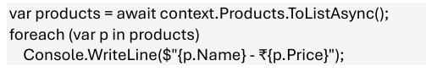

2. Find by ID:

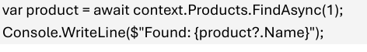

3. FirstOrDefault with Condition:

